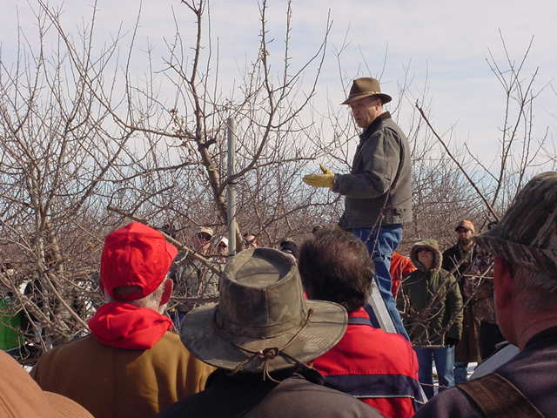
Tuscola Conservation District
Presents
APPLES PEARS PEACHES PLUMS
CHERRIES and vine fruits
Get the latest information
10TH annual fruit tree pruning workshop
With Bob Tritten, MSU Extension Fruit Educator for Southeast Michigan
- 3-hour intensive training and practice
- Learn basic care of fruit trees
- Learn to prune old trees, young trees, apples, pears, stone fruits
- Pruning to get good production every year
- Fertilizing, varmint and deer protection
- Planting techniques and pairing trees for better pollination
Wednesday, March 13th from 8:30 to Noon
Saginaw Valley Research and Extension Center
3775 S Reese Rd Frankenmuth 48734
(½ a mile south of M-46 on Reese Rd)
RSVP to Tuscola CD at 989-673-8174 ext. 3
Free of Charge-2019 Tree Order Forms will be available

