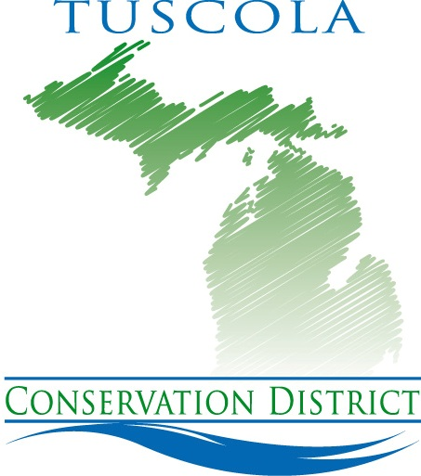

Tuscola Conservation District
1075 Cleaver Road
Caro, MI 48723

Check us out on the web www.tuscolacd.com

FALL 2014 ORDER FORM
Orders due by September 30, 2014
Pick-up date is October 11, 2014

E-MAIL orders to jim.kratz@mi.nacdnet.net
Telephone (989) 673 -8174 ext. 3

Conifer Seedlings | Size | 25 | 50 | 100 | 500 | 1000 | Quantity | Cost
White Pine (3-0) | 10-15” | $15 | $20 | $38 | $125 | $190
Red Pine (3-0) | 10-15” | $15 | $20 | $38 | $125 | $190
Blue Spruce (3-0) | 10-15” | $15 | $20 | $38 | $125 | $190
Norway Spruce (3-0) | 10-15” | $15 | $20 | $38 | $125 | $190
White Spruce (3-0) | 10-15” | $15 | $20 | $38 | $125 | $190

Conifer Transplants | Size | Age | Each | Quantity | Cost
Norway Spruce (2-2) | 15”+ | 4 year transplant | $1.50 each
White Spruce (2-2) | 15”+ | 4 year transplant | $1.50 each
Blue Spruce (2-2) | 15”+ | 4year transplant | $1.50 each
White Pine (2-2) | 15”+ | 4year transplant | $1.50 each
E. Hemlock (2-2) | 12-18” | 4 year transplant | $1.75 each
Balsam Fir (P-3) | 12-22” | 4 year transplant | $1.75 each
Fraser Fir (2-2) | 15-24” | 4 year transplant | $1.75 each
White Cedar (2-2) | 12-18” | 4 year transplant | $2.00 each
Husky Transplants | Size | Age | Each | Quantity | Cost
White Spruce (2-2) | 2’ + | 4 year transplant | $3.00 each
Norway Spruce (2-2) | 2’ + | 4 year transplant | $3.00 each
CO Blue Spruce (2-2) | 2’ + | 4 year transplant | $3.00 each
White Pine (2-2) | 2’+ | 4 year transplant | $3.00 each

Other Items | Cost | Quantity | Cost
Marking Flags | 10¢ ea. Bundles of 50
Diehard Rootdip Increases plant survival 3 oz. | $6
Tree Pro Tree Protectors 36” with stake | $3
Tree Planter (call to schedule) | $40.00 per day
Plantskydd deer repellent (2# soluble powder for 400-600 trees) | $39
Plantskydd (1# soluble powder for 200-300 trees) | $22
Plantskydd (1qt. spray bottle for 80-100 plants) | $24

PAYMENT
SUBTOTAL
6% SALES TAX
HANDLING FEE |  | $1.00
DEPOSIT
BALANCE DUE
For a complete description of the trees and to order online go to our website: tuscolacd.com

Please make checks payable to: TCD

--------------------------------------------------------------------------------------------------------------------------------------------
CUSTOMER INFORMATION – Please complete
Name:
Mailing Address:
City, State, Zip:
Daytime Phone: Home Phone:
Email (to receive future order forms):
FOR OFFICE USE  Order number:  Date Paid:  Check number:  Credit Card:  District Tree Sales are a major source of funding for conservation projects in our county. Thank you for your support. | Regular orders must have 25% down payment  Small orders should be paid in full if possible.  It is unlawful for these trees, shrubs, and other plants purchased from the District to be resold with the roots attached, in accordance with the Insect Pest and Plant Disease Act, P.A. 189 of 1931, as amended.  All Soil Conservation District programs and services are offered on a non-discriminatory basis without regard to race, color, national origin, religion, sex, age, marital status or handicap.

Thank you for your tree order! You will receive information in the mail approximately one week prior to the scheduled pick up date of October 11th

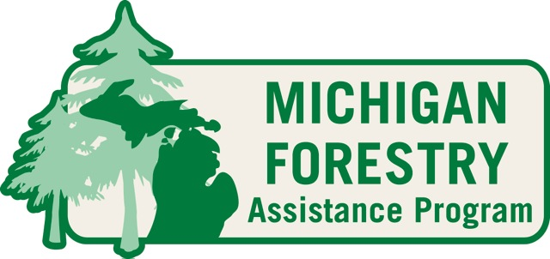
For free assistance on managing your woodlot or for information on forest management programs and cost-sharing, contact your conservation district forester.

Tyler Pederson 989-673-8174 x 3

