Reaching your Conservation Goals:
Programs and Assistance Available to You
CONSERVATION WORKSHOP

April 23, 2014
6:30-8:30 PM
Farm Bureau Insurance
711 North Van Dyke Road
Bad Axe
Contact Jeff Jones (989-673-8174 ext. 3) for information

COST: FREE!
BENEFITS: Learn about the programs and funding available to provide assistance towards achieving your conservation goals. The following speakers will talk about their agency’s programs that promote conservation.
Nathan Prill (USDA-FSA)
Michael Daskam (USDA-NRCS)
Michelle Vanderharr (USFWS)
Greg Renn (Huron Conservation District)
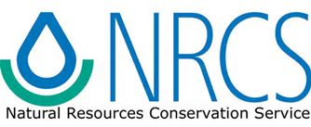
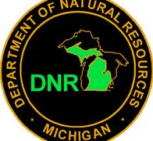
Mike Parker (Michigan DNR)
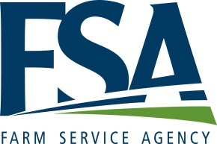
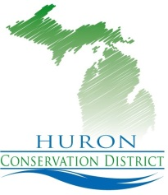
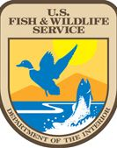
This partnership venture features representatives from several local conservation organizations

